OSU Medicine Remote Two Factor Authentication Self Enrollment
Access the portal using myaccess.saintfrancis.com
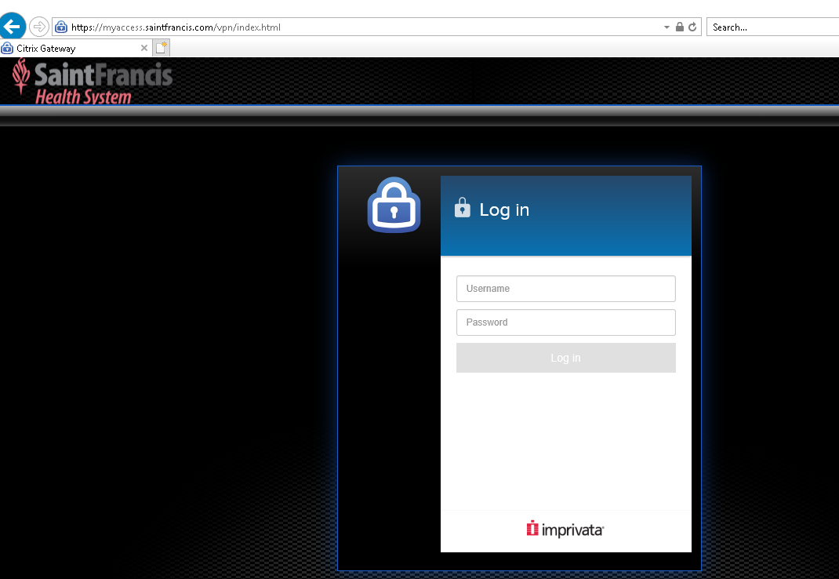

Enter the Login and Password in the Log in window. This is the same as the Epic Login / Password.
Imprivata will display an Enrollment message. The user needs to have the Imprivata ID App on their Smartphone.  Select the Enroll new Device | 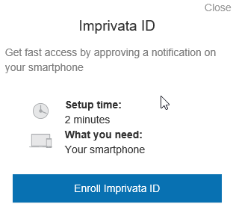

Using the Imprivata ID on the users Smart Phone. Enter the Serial Number (digits only) and Token Code.  Select the Submit button | 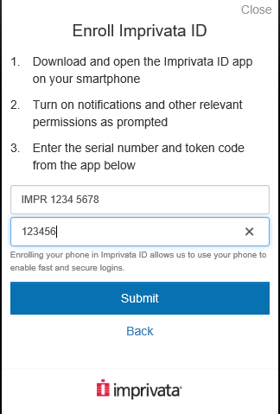

A confirmation screen will appear after successful self-enrollment.  Select the Done button to continue to the StoreFront Login screen. | 