

**College of Osteopathic Medicine**

**Office of Academic Success**

**MS-I/MS-II Pre-Clinical Coursework**

**Study Strategies Guidebook**

**TABLE OF CONTENTS**

Introduction………………………………….……………………………………………………………….…….2

Information Processing and Memory………………………………….…………………………….…2

Learning Style and Study Strategy Assessments…………….………………………………….….4

Stages of Studying …………………………………………………………………………………………….…5

Condensed Notes………………………………………………..……………………………………….………6

Time Management and Study Schedules ……………………………………………….…..……….6

Test Strategies……………………………………………………………………………….……………………7

Using Learning Objectives…………………………………………………………………………….…….8

Resources…………………………………………………………………………………………………….…….9

References…………………………………………………………………………………………………….….10

Appendices

Appendix A Type of Condensed Notes for the Task, Information and Course….….11

Appendix B Condensed Notes Examples…………………………………………………………….12

Appendix C Concept Mapping Instructions……………………………………………………..….15

Appendix D Academic Study Resource List……………………………………………….…….….16

Appendix E OSU-COM Wellness and Behavioral Health Resources……………………..20

**Introduction**

The academic demands of medical school require that students possess key study, learning and self-management strategies and skills to optimize academic performance. Research in the medical education community reveals scientifically supported evidence to guide medical students in the areas of studying, learning, and self-management. The purpose of this handbook is to share information and proven techniques for optimizing academic performance in the first and second years of medical school.

**Information Processing and Memory**

The volume of information students receive in medical school necessitates students to utilize evidence-based strategies to enhance memory. Long-term storage of information is especially important to medical students since board exam questions require medical students to retrieve and process information from foundational biomedical science courses and clinical systems courses taken during the first and second years of medical school.

The diagram below is a representation of information as it is processed through three levels: sensory input, working memory, and long-term memory.

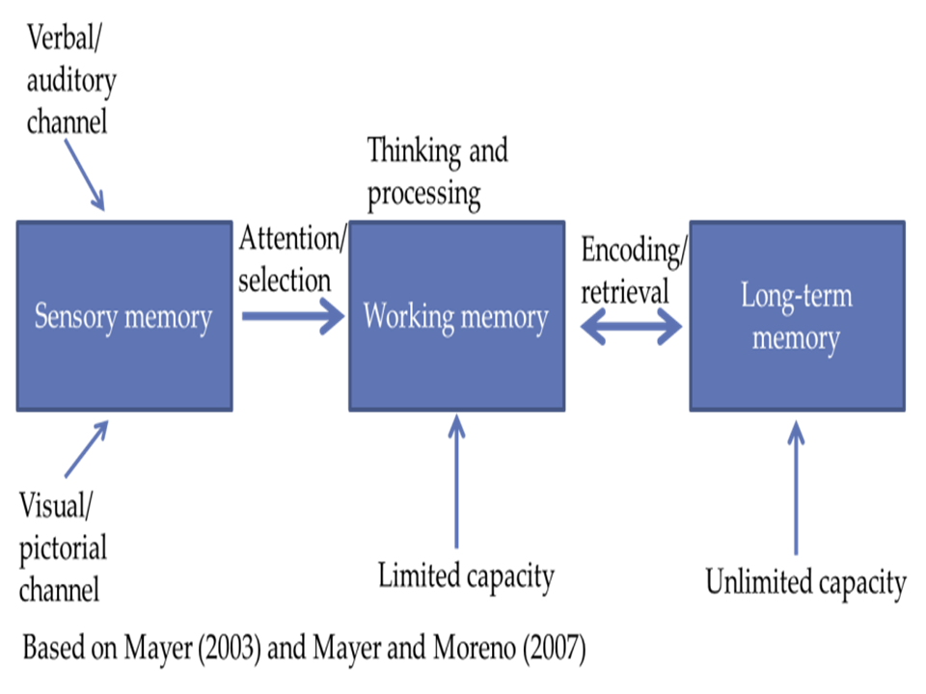

Vanderbilt University for Teaching licensed under CC BY 2.0.

***Sensory Memory***

Stimuli is screened and processed. Capacity is between 3-7 items and only for about 1-3 seconds.

***Working Memory:***

A capacity of 7 +/- 2 items of information is temporarily stored and manipulated for 5-15 seconds.

***Long-term memory:***

Information is permanently stored to be retrieved for later use.

***Spaced Repetition***

The German psychologist, Hermann Ebbinghaus, found that memory retention of information is reduced from 100% to 40% if not reviewed within the first few days of learning it (Shrestha, 2017). Spaced repetition is the review of information across spaced intervals and assists in overcoming this loss in memory. Massed practice (cramming) is the study of information in a short period of time directly before an exam. Spaced repetition improves performance and long-term retention of information better than massed practice (Kornell, 2009).

Research has been conducted to determine the optimal intervals for long-term retention. The first two integral time intervals are directly after lecture and the following day after a night’s sleep. (Peigneux, Laureys, Delbeuck, & Maquet, 2001). After those two intervals, the next interval varies based on the amount of time until the exam. The diagram below illustrates spaced repetition and retention.

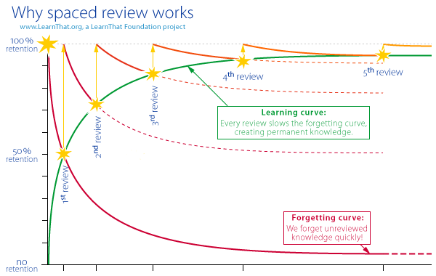

“Why spaced review works” by the LearnThat Foundation project is licensed under CC BY 2.0

As a student completes the spaced repetitions of information, there are strategies for more efficient and effective encoding and increased memorization such as:

* Mnemonics--memory devices created to help with memory retrieval
* Organization--clustering related content to show relationships
* Schema activation--connecting information by activating related prior knowledge
* Elaboration--increasing links between items of existing knowledge
* Imagery--forming mental pictures of information

***Final Tips for Information Processing and Memory***

1. Establish relationships between new information and previously learned information.
2. Use mnemonic devices.  Create your own or use some that are in First Aid and other supplemental resources.
3. Chunk information. Since working memory holds 7 +/-2 pieces of information at a time, chunking helps to group and organize larger “chunks” of information into smaller “chunks” of information to bring it from long-term memory into working memory. A phone number chunked into 739-456-2180 is easier to remember than 7394562180.
4. Visualize the information by using charts, tables, diagrams, color-coding, etc. to structure and organize the information.
5. Read out loud.  Research shows that reading information aloud while studying creates a stronger imprint on the mind and memory.
6. Avoid cramming.  Spaced reviews of the information allow it to move to long-term memory.
7. Set up a calendar with reminders and develop to-do lists.
8. Take care of your wellness with adequate sleep, exercise, mindfulness, and a healthy diet.
9. Stay focused by studying without distractions to reduce cognitive load.
10. Pre-test yourself over the information before the actual exam. Retrieving the information from memory before the exam strengthens neural pathways.

**Learning Style and Study Strategy Assessments**

Metacognition is the understanding of how a person learns and is an integral component of a medical student’s academic success. Oklahoma State University-College of Osteopathic Medicine (OSU-COM) uses multiple learning, personality, and developmental inventories to develop a comprehensive view of how its students learn, as well as, the student’s type of personality and self-management skills. These results are used to create a personalized plan for the student addressing any areas of improvement.

The learning and study strategy assessments that are administered and interpreted by the Learning Skills Specialist in the Office of Academic Success are:

Learning and Study Strategies Inventory (LASSI):

This inventory measures a student’s strengths in three components of learning: skill, will, and self-regulation. The skill component measures information processing, selecting main ideas and test strategies. The will component measures attitude, motivation, and anxiety. The self-regulation component measures concentration, time management, self-testing, and using academic resources.

Westside Test Anxiety Scale:

This ten-item scale measures manifestations of cognitive and emotional test anxiety. A score of three or higher indicates that the student will benefit from seeking out test anxiety reduction resources.

Nelson-Denny Reading Test:

This short test measures the reading ability of students and measures the student’s vocabulary, comprehension, and reading speed. The test can help identify if a student needs reading development. It does not diagnose reading disorders.

Visual, Auditory, Reading, and Kinesthetic Learning Modalities: This test explores a person’s preferred sensory modality for learning.

Myers-Briggs Type Indicator (MBTI): This self-report inventory identifies a person’s preferences and strengths based on a combination of four dichotomous scales: Extraversion (E)-Introversion (I), Sensing (S)-Intuition (N), Thinking (T)-Feeling (F), and Judging (J)-Perceiving (P).

Approaches to Study Inventory (ASI): This inventory is section B from the Approaches to Learning and Studying Inventory (ASSIST) and measures a student’s preference for a surface approach, deep approach, or a strategic approach to learning.

**Stages of Studying**

Preview Acquire Self-Test Spaced Repetition

**Preview (10% of study time)**

The goals of this stage of studying are to become familiar with the content of the next lecture, to familiarize yourself with the learning objectives, and to create more active learning during lecture. Previewing the subject content involves prereading the PowerPoints provided by the faculty as well as any assigned readings. Look up any terms that you don’t know and begin to develop questions about the information to listen for in the lecture. Previewing is also the time to begin to relate this new information to information that you have previously learned related to the content. Previewing allows the brain to begin to create connections and neural imprints for the information before lecture, and doing this will allow for more active, efficient, and effective acquisition of the information during lecture time.

**Acquire (70% of study time)**

This stage involves attending lecture and study groups, condensing your notes, completing study guides, and many other activities. It includes study activities that allow the student to understand and encode the information. The goal of this stage is to make the information make sense to you by elaborating on previously learned information and by identifying connections to why the information is important to know for becoming a physician.

**Self-Test (10% of study time)**

The testing effect is a widely studied topic in educational psychology. It reveals that a person remembers the information better when tested over the information. Self-testing also allows the student to identify knowledge gaps in the content. Self-testing activities include completing study guides without looking at the material, quizzing in study groups, completing practice questions, etc. Any activity that allows you to retrieve the information from memory is considered self-testing.

**Spaced Repetition (10% of study time)**

For the information to be retained, it is important to review the information at various intervals while studying and learning. Activities in this stage are reading over condensed notes, watching a short video over the content, talking it out with a classmate, etc. It is a refresher of the information and consolidates the information to make it more stable.

**Condensed Notes**

Creating condensed notes is a part of the acquisition stage of studying. These notes combine information from all the source material (e.g. course PowerPoints, handwritten notes, and required readings) into a condensed format for quick review and quick pre-testing. As there is too much information to reread lengthy narratives, condensed notes give structure and efficiency for quick reviews. Creating condensed notes allows students to determine what details are most important as well as to see the ‘big picture’ and allows students to mold the information into a way that makes sense to them.

The type of condensed notes to use depends on the subject matter, and the lecture objectives should guide the creation of the notes. Tables, diagrams, flash cards, and concept maps are examples of condensed notes. Appendix A contains a table taken from the book, *Study Without Stress,* by Kelman & Straker that details what type of condensed notes are best for the subject. Appendix B gives examples of the types of condensed notes. Appendix C gives instructions for creating mind maps, a type of condensed note used for overviews across disciplines and whole organ systems.

**Time Management and Study Schedules**

The medical student’s time is limited, but having a structured study schedule with specific goals for each study session helps a student to manage time. Study schedules help medical students to develop a set routine and to develop positive self-management habits. Routines take less energy than willpower.

There are some decisions to make when deciding on the structure of the study schedule. Will it be hand-written or electronic? Will it be a daily, weekly, or monthly calendar? How will progress be tracked through the material? Each student’s schedule will not look the same, but goals should be set for each study session and the four stages of studying previously discussed should be incorporated.

***Final Tips for Time Management:***

1. Anticipate and plan what you need to accomplish and in what time frame.
2. Use time management tools. Electronic apps have reminders.
3. Create goals for each study session.
4. Be realistic with the number of tasks that can be completed in the time that you’ve scheduled as to not overload yourself.
5. Use the Pomodoro Technique by either studying 50 minutes and then taking a 10-minute break or studying 25 minutes and taking a 5-minute break.
6. Stay away from electronic screens during breaks.
7. Schedule difficult tasks when you know your energy is highest.
8. Don’t get frustrated if you don’t always stay on schedule.
9. Study in a place with limited distractions
10. Incorporate wellness into the schedule. Exercise, adequate sleep, and some relaxation/ activities/ hobbies are all part of the learning process as well.
11. A general rule of thumb is to spend 2/3 of your time studying for the next upcoming exam and then split the remaining 1/3 of your time on your other courses (Ex. If you study 9 hours a day, then 6 hours should be spent on the upcoming exam and 3 hours on other courses). Also, take into account the difficulty of the course—some courses do take more time.
12. When making a study schedule, section off the time for the subject and color-code it specific for that class.

**Test Strategies**

Medical students are required to take many multiple-choice exams throughout medical school. The following strategies are provided to help students maximize points on multiple choice exams.

**Before the test:**

* Incorporate practice questions into studying to get into a test-taking mode.
* Don’t change habits too much right before the day of the test.
* Try to sleep 7-8 hours the night before exams. Avoid staying up late to cram.
* Practice techniques to reduce test anxiety and increase focus.
* Visualize yourself feeling and looking proud and confident at the completion of the exam.

**During the test:**

* Look over the test to decide how much time to spend per item. Mark on the test where you should be when half of the time has elapsed.
* Answer the easy questions.
* If you get stuck on a more difficult question, mark it and move on to the next one.
* Reduce anxiety with breathing and good posture.

**After the test:**

* Review your test.
* Identify the source(s) of your mistakes. Probable causes:
  + Insufficient preparation
  + Failure to use good test-taking strategies
  + Test anxiety
  + Seek out resources for improvement on the next exam.

**Multiple-choice Question Clinical Vignettes:**

1. Carefully read the question. Highlight details in case you need to return to the question later.
2. Process the question as you read the entire stem word-for-word.
3. Read the question again.
4. If you are certain of the answer, answer it and move on. Do not overanalyze.
5. But, if you do not know the answer, eliminate any easily identifiable wrong answers. If you are still uncertain, flag the question and go back to it later.
6. If you narrow it down to two answer choices, go back to the question stem and ask yourself what makes each of the choices right or wrong. Decide which answer fits best in this manner.

**Mistakes to Avoid:**

* Guessing too quickly
* Overthinking
* Random guessing
* Skipping words by reading too quickly
* Looking too hard for the right answer and not eliminating wrong answers
* Changing answers; only change an answer if you are suddenly certain the answer you chose is wrong and you know the correct answer now.
* Wasting time by overanalyzing after choosing an answer
* Reading the answer choices (distractors) first before reading the question stem; this creates
* bias in which the test-taker tries to make the question fit an answer choice

**Using Learning Objectives**

Course faculty use learning objectives in each lecture to align curriculum and identify the outcomes that are expected for each student. Using the learning objectives to guide studying is imperative to preparing for the course exams.

***Three Simple Steps for Using Learning Objectives (LOs)***

1. Number the objectives and then number the PowerPoint (ppt) to know where the information is found in the ppt. If there are many LOs, combine the ones that are similar to save time.
2. Answer the LOs by creating diagrams, tables, flowcharts, etc. instead of a lengthy narrative, and color-code them as well. Use information from the ppt, lecture notes, and other content source material.
3. After you’ve answered the LOs and created your condensed notes, teach it on a whiteboard to someone or an invisible person using the visual, auditory, and kinesthetic modalities of learning. Doing this also allows you to test yourself over the information and to eliminate knowledge gaps.

***Final Tips for Using Learning Objectives (LOs)***

1. If there are many LOs, combine the ones that are similar to save time.
2. Use a timer for each lecture so that you are able to get through all of the LOs and not get “stuck” on one content area and miss the rest of the information.
3. Divide and conquer LOs with students by splitting them up with other students that you trust.
4. If you are teaching the information to others on a whiteboard, begin with the LO that you have the most trouble with understanding. Let others correct you if needed. Then, when you are listening to peers, make sure the person is correct.

**Resources**

A list of academic resources can be found in Appendix D of this guidebook. OSU-COM’s Medical Library offers numerous academic resources to medical students; however, those resources with an asterisk on this list are not provided by the medical library. An A-Z list of resources in OSU-COM’s Medical Library can be found at this site: <https://libraryguides.health.okstate.edu/az.php>.

OSU-COM promotes and supports student wellness. Appendix E lists wellness and behavioral health resources that are available for medical students.

**References**

Kelman, E. G., & Straker, K. C. (2000). *Study without stress mastering medical sciences*. Thousand Oaks: Sage Publications.

Kornell, N., (2009). Optimizing Learning Using Flashcards: Spacing Is More Effective Than Cramming. *Applied Cognitive Psychology*, 23, 1297-1317.

MyFinalsNotes Home Page. (2019). Retrieved July 15, 2019, from https://www.myfinalsnotes.com/

Peigneux, P., Laureys, S., Delbeuck, X., & Maquet, P. (2001). Sleeping brain, learning brain. The role of sleep for memory systems. *NeuroReport*, 12, A111-A124.

Pelley, J., MBA, PhD. (2019). Success Types Medical Education Site. Retrieved May 29, 2019, from <https://www.ttuhsc.edu/medicine/medical-education/success-types/default.aspx>

Praveen Shrestha, “Ebbinghaus Forgetting Curve,” in Psychostudy, November 17, 2017, https://www.psychstudy.com/cognitive/memory/ebbinghaus-forgetting-curve.

Schellenberg, S., Negishi, M., Eggen, P. (2011). The Effects of Metacognition and Concrete Encoding Strategies on Depth of Understanding in Educational Psychology. *Teaching Educational Psychology*, 17-24.

**Appendix A**

|  |  |  |  |
| --- | --- | --- | --- |
| **If the task is to** | **And the Information Is** | **Make This Type of Note** | **Examples** |
| Associate a name with a location | Static /unchanging and related information is due only to location | Diagram | Gross Anatomy |
| Compare and contrast or classify a set of main topics according to a set of similar details | Static/unchanging | Category Chart | Pharmacology, microbiology, diseases (e.g. pathology or internal medicine) |
| Associate a complicated series of names, procedures, or functions | Changing in a temporal chronological sequence or cause/effect sequence | Flowchart | Biochemistry, parasitic life cycles, physiology, or any process |
| Associate complicated but related set | Static/unchanging | Combine diagram with a category chart | Histology, neuroscience |
| Compare and contrast and see contacts between more than one complicated, but related, process | Changing in a temporal/chronological | Combine flowchart by categories | Endocrinology |
| Recall unrelated, specific information (e.g. definitions or formulas); very small charts; or details from larger charts that you still need to learn | Not complicated enough to require a full 8 1/2" x 11" sheet of paper | 3" x 5" cards | Any class |
| To get the "big picture" of a topic at a conceptual level | Irregular, complex associations-including cause and effect | Map | Overview, across disciplines, whole systems |

**\*Figure 1. Type of Condensed Notes for the Task, Information, and Course by Taken from Study without Stress by Eugenia G. Kelman and Kathleen C. Straker**

**Appendix B**

**Condensed Notes Examples**

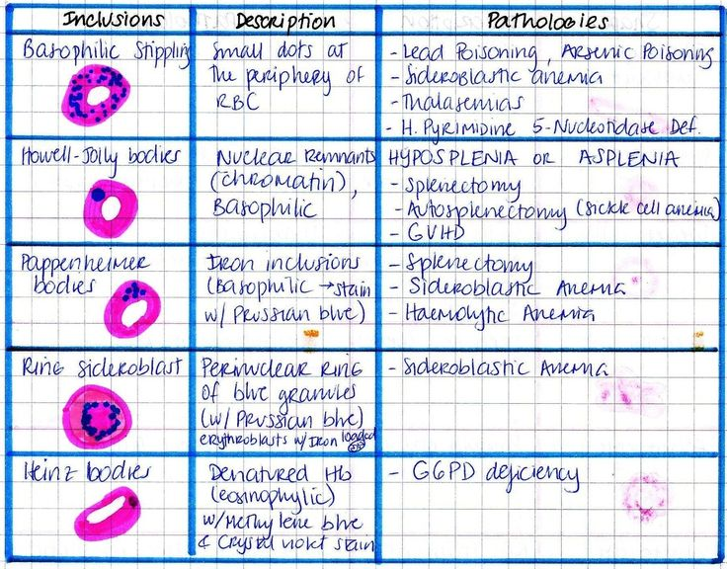

**Figure 2. Condensed Notes Example: Table**

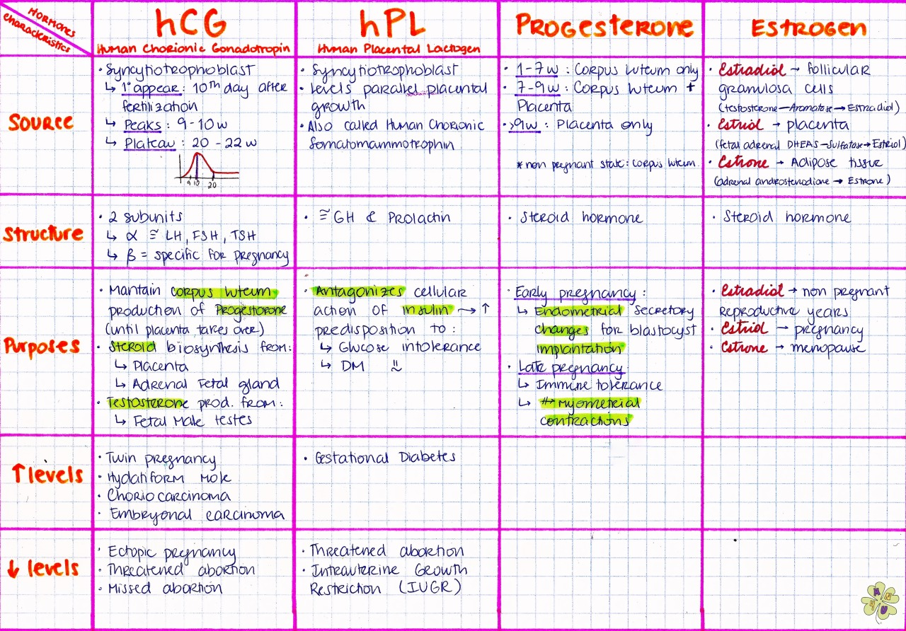

**Figure 3. Condensed Notes Example: Table**

**Appendix B (Continued)**

**Condensed Notes Examples**

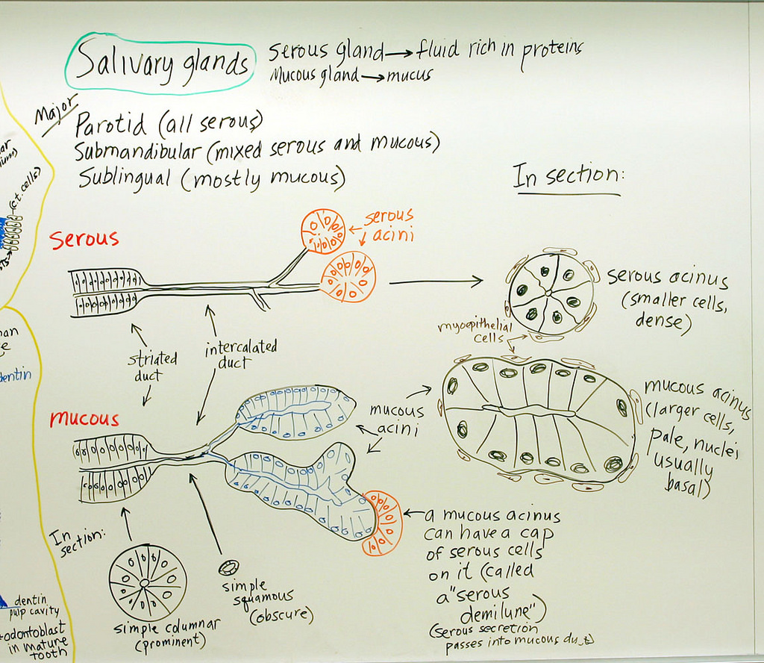

**Figure 4. Condensed Notes Example: Diagram**

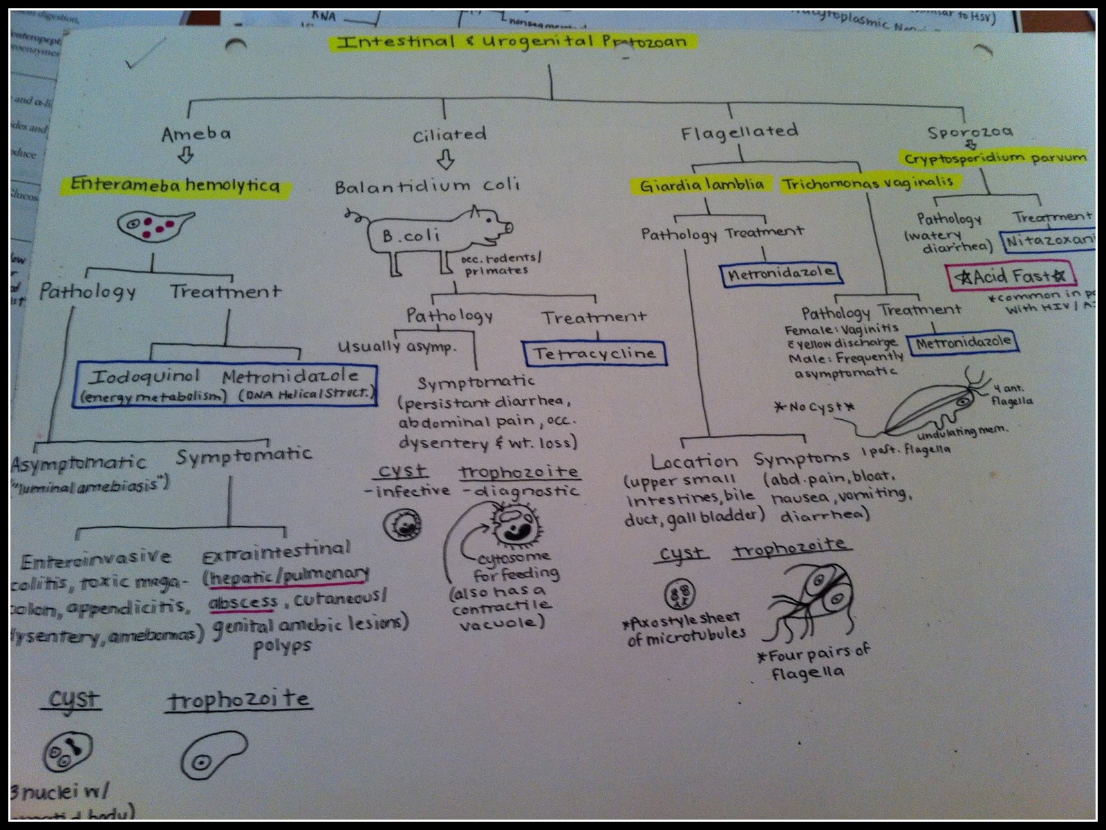

**Figure 5. Condensed Notes Example: Flowchart**

**Appendix B (Continued)**

**Condensed Notes Examples**

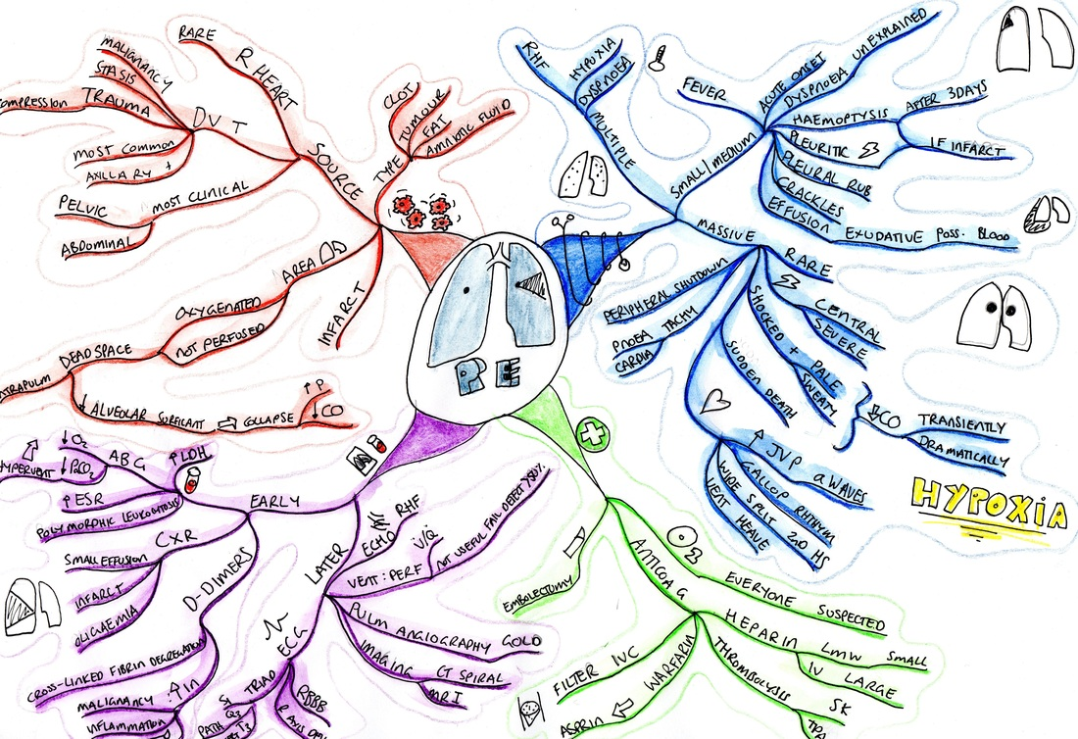

**Figure 6. Condensed Notes Example: Concept Map from myfinalsnotes.com (2019)**

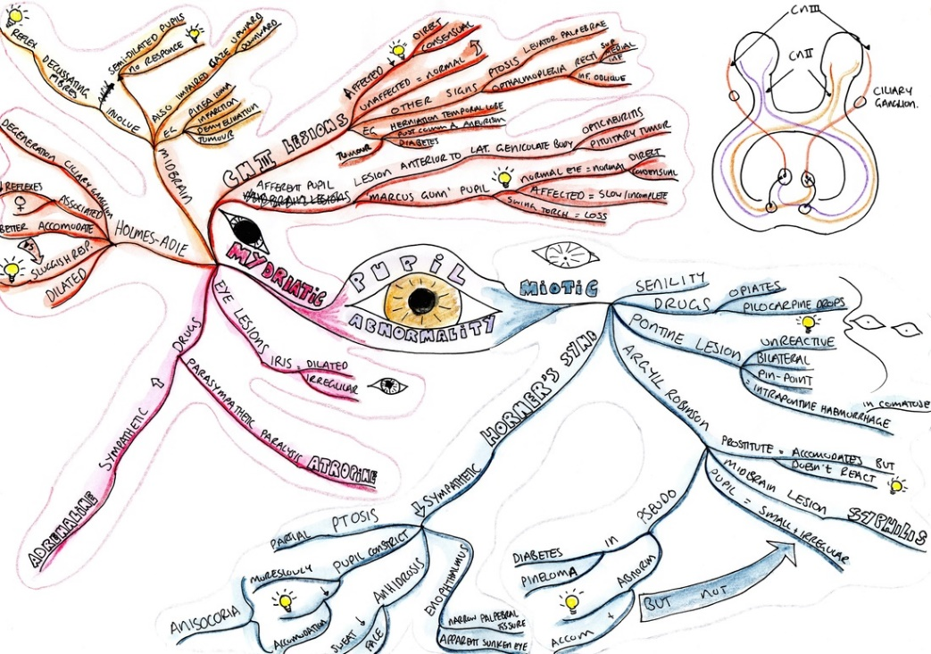

**Figure 7. Condensed Notes Example: Concept Map from myfinalsnotes.com (2019)**

**Appendix C**

**Concept Mapping Instructions**

1. **Listing**-First Step
   1. This process creates a short list that will develop into an overview outline.
      1. Determine what is general and what is specific.
         1. Ex. Continents, then states, then counties or regions
      2. Decisions answer the question, “Is this a major topic that groups other topics within it?”
2. **Grouping**—Second Step
   1. This process visually identifies general topics or subtopics and then creates an overview
      1. On the list, mark (highlight, underline, circle) the most general topics.
      2. Identify and use a different marking for terms that belong under each of those headings.
      3. Now, start your map at the top of the page.
         1. Link the general bubbles so they branch and spread out downwardly creating an overview map. It can be changed later but it’s a good starting point.
         2. Now, do the detailed reading of the material and find the terms that group under each of the general bubbles.
         3. As you continue to learn, you will add more bubbles and branches adding more details and connections.
3. **Comparing**—Third Step
   1. In this process, you find connections between branches rather than straight down groupings.
      1. Find concepts that are similar, different, or that show cause-and-effect.
      2. Allows you to link together observations not originally presented in lecture or in reading.
      3. You may have to draw long, winding, stretched-out links across your map, but this gets better and neater with experience.
4. **Sharing**—Fourth Step
   1. This process allows you to increase thinking skills or increase in long-term memory.
      1. Speak the entire map out loud beginning at the top.
         1. Use it to make a lecture to give to a partner or pet.
         2. This helps to identify misunderstandings to clarify before the exam.

*Note.* Success Types Medical Education Site by J. Pelley (2019). Adapted with permission.

**Appendix D**

**Academic Study Resource List**

|  |  |  |  |  |
| --- | --- | --- | --- | --- |
|  |  |  |  |  |
|  |  |  | **Type** |
| **Electronic Apps** |  |  |  |  |
| Anki* | Flash Cards |  |  | Test/2200q |
| Cram Fighter* | Study Schedule |  |  | Test/2500q |
| Firecracker (Comprehensive learning platform)*  Osmosis (Comprehensive learning platform)* |  |  |  | Test/2200q |
| Pixorize (Biochemistry)* | Review |  |  | Test/2500q |
| SketchyMedical (Micro, Pharm, Path)* | Review |  |  |  |
| Pathoma (Pathology)* | Review |  |  |  |
| **Comprehensive** |  |  |  |  |
| USMLE Step 1 Secrets | Review |  |  | Test/1000q |
| First Aid Cases for the USMLE Step 1 | Cases |  |  | Test/850q |
| First Aid for the Basic Sciences: General | Review |  |  | Test/322q |
| First Aid for the Basic Sciences: Organ Systems | Review |  |  | Tet/1200q |
| medEssentials for the USMLE Step 1 | Review |  |  |  |
| Cases & Concepts Step 1: Basic Science Review | Cases |  |  |  |
| Step-Up to USMLE Step 1 | Review |  |  | Review/Test |
| Cracking the USMLE Step 1* | Review |  |  | Review/Test |
| USMLE Images for the Boards: A Comprehensive Image-Based Review* | Review |  |  | Review/Test |
| Deja Review: USMLE Step 1 | Review |  |  | Cases/Test |
| USMLE Step 1 Made Ridiculously Simple | Review/Test/100q |  |  | Review/Test |
| **Anatomy, Embryology, and Neuroscience** |  |  |  | Review/Test/1300q |
| High-Yield Embryology | Review |  |  | Review |
| High-Yield Neuroanatomy | Review/Test/50q |  |  | Review |
| Anatomy-An Essential Textbook* | Text/Test/400q |  |  | Review |
| Atlas of Anatomy | Text/Test/400q |  |  | Review |
| High-Yield Gross Anatomy | Review |  |  | Review |
| Clinical Anatomy Made Ridiculously Simple* | Review |  |  | Review |
| Rapid Review: Gross and Developmental Anatomy | Review/Test/450q |  |  |  |
| PreTest Neuroscience | Test/500q |  |  |  |
| Crash Course: Anatomy | Review |  |  |  |
| Deja Review: Neuroscience* | Review |  |  |  |
| USMLE Road Map: Neuroscience* | Review/Test/300q |  |  |  |
| BRS Embryology | Review/Test/220q |  |  |  |
| Anatomy Flash Cards | Flash Cards |  |  |  |
| Clinical Neuroanatomy Made Ridiculously Simple | Review/Test/Few q |  |  |  |
| Case Files: Anatomy | Cases |  |  |  |
| **Appendix D (Continued)**  **Academic Study Resource List**  Case Files: Neuroscience | Cases |  |  |  |
| Gray's Anatomy for Students Flash Cards | Flash Cards |  |  |  |
| Netter's Anatomy Flash Cards | Flash Cards |  |  |  |
| **Behavioral Science** |  |  |  |  |
| High-Yield Behavioral Science | Review |  |  |  |
| BRS Behavioral Science | Review/Test/700q |  |  |  |
| High-Yield Biostatistics, Epidemiology and Public Health* | Review |  |  |  |
| Clinical Biostatistics and Epidemiology Made Ridiculously Simple | Review |  |  |  |
| USMLE Medical Ethics* | Cases |  |  |  |
| Jekel's Epidemiology, Biostatistics, Preventative Medicine, and Public Health | Review/Test/477q |  |  |  |
| Deja Review: Behavioral Science* | Review |  |  |  |
| **Biochemistry** |  |  |  |  |
| Lange Flash Cards Biochemistry and Genetics | Flash Cards |  |  |  |
| Rapid Review: Biochemistry | Review/Test/350q |  |  |  |
| Lippincott's Illustrated Reviews: Biochemistry* | Review/Test/500q |  |  |  |
| Deja Review: Biochemistry | Review |  |  |  |
| Medical Biochemistry-An Illustrated Review* | Review/Test/400q |  |  |  |
| PreTest Biochemistry and Genetics* | Test/500q |  |  |  |
| Clinical Biochemistry Made Ridiculously Simple* | Review |  |  |  |
| BRS Biochemistry, Molecular Biology, and Genetics | Review/Test |  |  |  |
| Case Files: Biochemistry | Cases |  |  |  |
| High-Yield Biochemistry | Review |  |  |  |
| **Cell Biology and Histology** |  |  |  |  |
| High-Yield Cell and Molecular Biology | Review |  |  |  |
| Elsevier's Integrated Review: Genetics* | Review |  |  |  |
| High-Yield Genetics | Review |  |  |  |
| BRS Cell Biology and Histology | Test/320q |  |  |  |
| PreTest Anatomy, Histology, and Cell Biology | Test/500q |  |  |  |
| USMLE Road Map: Genetics* | Review |  |  |  |
| Deja Review: Histology and Cell Biology | Review |  |  |  |
| Crash Course: Cell Biology and Genetics | Review |  |  |  |
| Wheater's Functional Histology | Text |  |  |  |
| **Microbiology and Immunology** |  |  |  |  |
| Deja Review: Microbiology & Immunology | Review |  |  |  |
| Clinical Microbiology Made Ridiculously Simple | Review |  |  |  |
| Lange Microbiology & Infectious Diseases Flash Cards | Flash Cards |  |  |  |
| **Appendix D (Continued)**  **Academic Study Resource List**  Basic Immunology | Review |  |  |  |
| The Big Picture: Medical Microbiology | Review/100q |  |  |  |
| Microcards: Microbiology Flash Cards* | Flash Cards |  |  |  |
| Lange Review of Medical Microbiology and Immunology | Text/Test/654q |  |  |  |
| Medical Microbiology and Immunology Flash Cards* | Flash Cards |  |  |  |
| Elsevier's Integrated Immunology and Microbiology* | Review |  |  |  |
| Lippincott's Illustrated Reviews: Immunology | Review/Test/Few q |  |  |  |
| Lippincott's Illustrated Reviews: Microbiology | Review/Test/Few q |  |  |  |
| Review of Medical Microbiology and Immunology | Review/Test/654q |  |  |  |
| Case Studies in Immunology: Clinical Companion | Cases |  |  |  |
| Pretest: Microbiology | Test/500q |  |  |  |
| Rapid Review: Microbiology and Immunology | Review/Test/400q |  |  |  |
| Case Files: Microbiology | Cases |  |  |  |
| **Pathology** |  |  |  |  |
| Rapid Review: Pathology | Review/Test/400q |  |  |  |
| Pathoma: Fundamentals of Pathology* | Review/Lecture |  |  |  |
| Lange Pathology Flash Cards | Flash Cards |  |  |  |
| Deja Review: Pathology* | Review/Test/400q |  |  |  |
| Lippincott's Illustrated Q&A Review of Rubin's Pathology* | Test/1000q |  |  |  |
| The Big Picture: Pathology | Review/Test/130q |  |  |  |
| Robbins and Cotran Review of Pathology | Test/1100q |  |  |  |
| BRS Pathology* | Review/Test/450q |  |  |  |
| Cases & Concepts Step 1: Pathophysiology | Cases |  |  |  |
| Case Files: Pathology | Cases |  |  |  |
| USMLE Road Map: Pathology | Review/Test/500q |  |  |  |
| PreTest Pathology | Test/500q |  |  |  |
| High-Yield Histopathology | Review |  |  |  |
| Pathophysiology of Disease: Introduction to Clinical Medicine | Text/Test/Few q |  |  |  |
| Hematology at a Glance* | Review |  |  |  |
| PreTest Pathophysiology* | Test/500q |  |  |  |
| Color Atlas of Physiology* | Review |  |  |  |
| Crash Course: Pathology* | Review |  |  |  |
| Pocket Companion to Robbins and Cotran Pathologic Basis of Disease | Review |  |  |  |
| **Pharmacology** |  |  |  |  |
| Deja Review: Pharmacology | Review |  |  |  |
| Lange Pharmacology Flash Cards | Flash Cards |  |  |  |
| Kaplan Medical USMLE Pharmacology and Treatment* | Flash Cards |  |  |  |
|  |  |  |  |  |
| **Appendix D (Continued)**  **Academic Study Resource List**  Lippincott's Illustrated Reviews: Pharmacology  Pharm Cards: Review Cards for Medical Students | Review/Test/380q  Flash Cards |  |  |  |
| Crash Course: Pharmacology | Review |  |  |  |
| Pharmacology Flash Cards | Flash Cards |  |  |  |
| Elsevier's Integrated Pharmacology | Review |  |  |  |
| Rapid Review: Pharmacology | Review/Test/450q |  |  |  |
| BRS Pharmacology | Review/Test/200q |  |  |  |
| Katzung & Trevor's Pharmacology: Examination and Board Review | Review/Test/1000q |  |  |  |
| PreTest Pharmacology | Test/500q |  |  |  |
| Case Files: Pharmacology | Cases |  |  |  |
| High-Yield Pharmacology | Review |  |  |  |
| **Physiology** |  |  |  |  |
| BRS Physiology | Review/Test/350q |  |  |  |
| Acid-Base, Fluids, and Electrolytes Made Ridiculously Simple | Review |  |  |  |
| Physiology | Text |  |  |  |
| The Big Picture: Medical Physiology | Review/Test/108q |  |  |  |
| BRS Physiology Cases and Problems | Cases* |  |  |  |
| Deja Review: Physiology | Review* |  |  |  |
| PreTest Physiology | Test/500q |  |  |  |
| Rapid Review: Physiology | Test/350q |  |  |  |
| Vander's Renal Physiology | Text |  |  |  |
| Endocrine Physiology | Review |  |  |  |
| Netter's Physiology Flash Cards | Flash Cards |  |  |  |
| Case Files: Physiology | Cases |  |  |  |
| Pulmonary Pathophysiology: The Essentials | Review/Test/50q |  |  |  |
| Clinical Physiology Made Ridiculously Simple | Review |  |  |  |
| **Question Banks** | | | | |
| Kaplan for Level 1/Step 1 (MSII access)  TrueLearn (COMBANK)  COMQUEST*  USMLE World (UWorld)* | | | | |
|  | | | | |
|  | | | | |
| **Question Books** | | | | |
| First Aid Q&A for the USMLE Step 1 | | | | |
| Kaplan USMLE Step 1 Qbook | | | | |
| PreTest Clinical Vignettes for the USMLE Step 1 | | | | |
| Lange Q&A: USMLE Step 1 | | | | |

*These resources are not available through the medical library.

**Appendix E**

**OSU-CHS Wellness and Behavioral Health Resources**

ComPsych Guidance Resources

* OSU-CHS offers confidential counselors with the Student Assistance Program (SAP) through ComPsych GuidanceResources. **All OSU-CHS students and residents**have access**24/7**to talk with a ComPsych counselor who will listen to your concerns and can guide you to the appropriate services you require.  ComPsych counselors are available to provide “in-the-moment” support by calling **866-519-8354.**
* If talking with the ComPsych counselor leads to a referral for counseling, you are entitled to **10 free counseling sessions** arranged with a local provider. **Telephone counseling is also available by appointment**.
* At the time of your call to ComPsych, the counselor will conduct an assessment and then provide referral information to you in one of several ways.
  + In routine situations, you can expect to receive a call back from the ComPsych counselor within approximately a day or so after your initial call, who will provide the name of a local counselor who is available to see you for an appointment.  We have been advised that once you contact the local provider, you should be able to be seen within approximately 3-5 days.
  + If an urgent appointment is needed, you will be contacted as soon as a provider is located; depending on the time of the initial call, it may be the next day before you receive the provider’s information.
  + In crisis situations, the ComPsych counselor will assess your needs and make a determination about the next level of assistance needed.
* ComPsych also has information available online on a range of topics (e.g., relationships, wellness, lifestyle, financial, etc), which can found at [guidanceresources.com](http://www.guidanceresources.com/). To access for the first time, click the link for REGISTER, enter OKSTATESAP as your Web ID, and then create your user ID and password.  **You can also call 866-519-8354***and speak with a counselor* to inquire about various topics.

On campus support:

Dr. Kelly Dunn M.D., Clinical Assistant Professor of Psychiatry, is available to see students for coaching and behavioral health services.  Visits are at no-cost and confidential.  All students are welcome to stop by her office at A-329 or schedule an appointment at this link:   <https://app.acuityscheduling.com/schedule.php?owner=16294188>

**Appendix E (Continued)**

**OSU-CHS Wellness and Behavioral Health Resources**

OSU-Tulsa Counseling Clinic

* The OSU-Tulsa Counseling Clinic is available to see students and residents for 5 free counseling sessions. Additional sessions are $5/per session.  Appointments can be set by calling **918-594-8568**.   The OSU-Tulsa Counseling Clinic is located on the OSU-Tulsa campus at 700 N. Greenwood, in Main Hall room 2419.

COPES

* In the Tulsa community, crisis intervention is available through COPES (Community Outreach Psychiatric Emergency Services) of Family and Children’s Services. COPES is confidential and free for persons in Tulsa County.  For immediate help, call **918-744-4800.** For more information, see <http://www.fcsok.org/services/crisiscare-center-2/mobile-crisis-copes/>.

**Suicide Prevention Hotline**:  1-800-273-8255

Well-being Resources

Below is a listing of wellness resources that may be of interest to you. For details regarding these resources and their use, please refer to the information on the specific site.

Mental health screening sites:

<https://wellmd.stanford.edu/test-yourself.html>

<https://screening.mentalhealthamerica.net/screening-tools>

Well-being Mobile Applications

**selected from Family and Children’s website (May 2018)

<https://www.fcsok.org/resources/apps/>

Mindfulness Coach

<https://apps.apple.com/us/app/mindfulness-coach/id804284729>

Headspace: meditation

<https://apps.apple.com/us/app/headspace-guided-meditation/id493145008>

Virtual Hope Box

<https://apps.apple.com/us/app/virtual-hope-box/id825099621>

Calm

<https://apps.apple.com/us/app/calm-meditation-techniques/id571800810>

I am: daily positive reminders

<https://apps.apple.com/us/app/i-am-daily-positive-reminders/id874656917>

**Appendix E (Continued)**

**OSU-CHS Wellness and Behavioral Health Resources**

**Wellness Center**

Services

Fitness Assessments, Wellness Coaching, Weight Room Orientations, Blood Pressure Screening, Intramural Sports, and much more

Free to Students/Residents/Fellows

Hours of Operation

Monday-Sunday

5:00 a.m.-12:00 a.m.

OSU-CHS Campus, Barson 1st Floor

Phone: 918-561-8272

Email: [chs.wellness@okstate.edu](mailto:chs.wellness@okstate.edu)

**Wellness Program and Events**

Please Contact:

Jesse Chaffin, Health and Wellness Manager  
918-561-1428   
[jesse.chaffin@okstate.edu](mailto:jesse.chaffin@okstate.edu)