HOW TO VIEW APPLICANTS

Log in to PageUp portal using single sign on. You will go through my.okstate.edu > Employee Tab > Talent Management System. Click on Administration.

**URL**: https://osu.dc4.pageuppeople.com/

Select *view applications*, The blue person button to the right of theposition you want to review applicants on

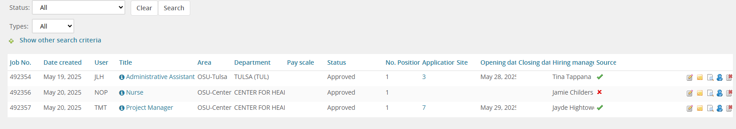

Click on Applicant name to view Applicant Information. It will appear as a slide out on the right hand side of the screen. When you click on the resume it will automatically give an AI short overview. We always recommend you review the full resume. When you are ready to choose your top candidate, you can press the Progress button.

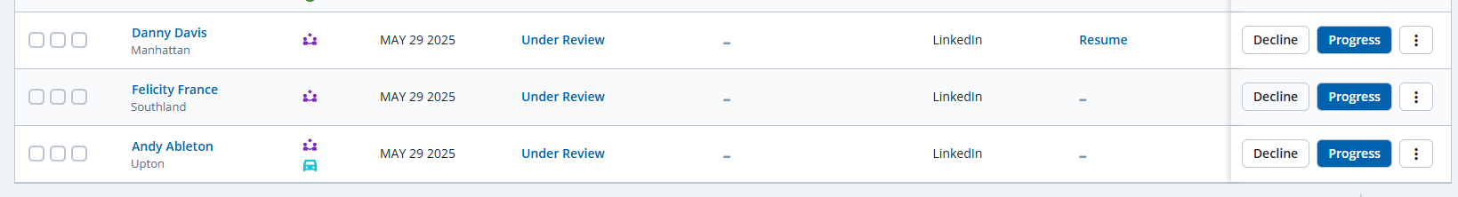

Once you have pressed progress, a pop-up will appear, select the appropriate status for the applicant then select *move now.* You will be able to move through *Under Review, Interview, and Reference Check.* We recommend that you notify the candidate about an interview or that you are conducting reference checks BEFORE you progress them to these statuses as they will receive an email notification as does HR.

When you choose *Reference Check* the system will send an email notification to the 3 references the applicant entered in their application. They will receive a reference questionnaire and they can have up to 3 business days to complete the questionnaire. Any completed reference checks will show up on the documents section. You can also choose to do your own reference checks and make phone calls if you would like. If you do this, then DO NOT progress the applicant to *Reference Check*. Leave the applicant in Under Review or Interview status.

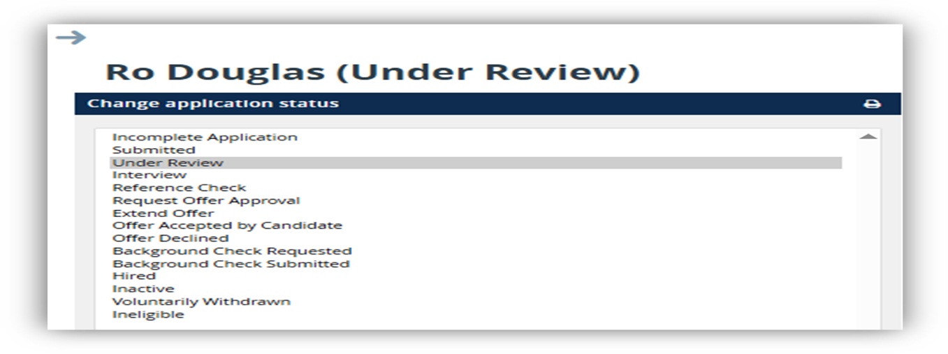

Please do not decline any applicant. Work with your HR Consultant, to close a position as declining will send a notification to the applicant and we want to make sure they receive the correct disposition and communication

Please review the video for Managing Applicants and the Recruitment Process within PageUp for more detailed information on the HR website at: <https://medicine.okstate.edu/hr/page-up-implementation.html>