

**Staff Advisory Council – Minutes**

The Staff Advisory Council will meet on **October 15th, 2019 at 12:00 pm,**

**Tandy Academic Medical Building, Room 353**.

All meetings are open to all staff of OSUCHS.

1. **Call to Order:** Sherrita Sweet- 12:00pm
2. **Roll Call:** Michelle Loveless
3. **Approval of Minutes:** 8/27/19 meeting and 9/17/19 meeting, no quorum to vote.
4. **Approval of the Agenda**: no quorum to vote.
5. **Reports of University Committees:**
   * **Administration-** Eric Polak
     + Facilities
       1. Gym construction continues, flooring on backorder. Supposed to be in by the end of the month. Equipment will be here the 21st if flooring is done.
       2. North Hall: Construction will start in April/May, will take about two years. Will start demoing Dunlap and Sky Bridge to make more parking; look to start in late Nov/Dec, more details about parking while that happens coming later.
       3. Will be building a loading dock on 17th street, so no more traffic into the heart of campus once the Medical Examiner’s office moves to new North Hall building.
       4. Legacy Plaza: gifted floors from Zarrow Foundation. Construction will continue through November. Will move departments in in phases as floors become completed. Psych and Behavioral Health Clinic, Project ECHO, Center for Wellness and Recovery administration, Center for Indigenous Health and Policy, back office functionality of CHS, and Pain Management Clinic will all be in Legacy.
       5. Tahlequah campus- Construction is a couple of weeks behind, but no current concerns about missing any critical deadlines. First class is still set to be in the Fall of 2020.
     + News release: Center for Wellness and Recovery settlement with Purdue Pharmaceuticals- what we are gaining is the possession of all the research Purdue has done, their pharmaceutical compounds; we become the gatekeeper of all that in order to do good with the knowledge they acquired.
     + Working with students and IT- Wi-Fi access and connectivity issues. LOTS of devices that are connecting to the system. Be aware and thoughtful of all your devices that are connecting to the Wi-Fi (watch, tablets, phone, computers).
     + Oct 24th- Wear Purple Day. October is Domestic Violence Awareness month. Wristbands are available in Student Affairs Office.
   * **HR-** Tina Tappana
     + Suggestion from SAC suggestion box about sharing/donating sick leave: Topic is reviewed every year. Stillwater HR, September 12, 2018, shared presentation about why we cannot share sick leave.
       1. Very few employees (less than 1%) end up with leave without pay due to our generous sick leave policy. We get 22 days/year of sick leave; average is 14 across the Big 12. Reality is, the budget is down 24.3% since FY2015, so that leaves little room for rebalancing our benefits. If we did a shared leave program, it would be a “new benefit” offering, and we would have to rebalance ALL benefits.
       2. Questions? Tanya O’Grady- If you are on FMLA, you can use sick leave for that, right? **Yes**.
     + Title 9 Training- sending out follow-up emails to everyone who haven’t completed it. Please go online and do that if you get email from us.
     + Benefits Open Enrollment training coming up; can just show up, don’t have to enroll for a training. Everyone has to go online and check their benefits, even if you are not changing anything. We are getting new vision and dental providers this year so action is required starting Nov 1.
   * **Security-** Meagan Robertson
     + Cleary Report is now available online
     + Striker chairs for every clinic/campus; evacuation chairs; expect training on how to use those if need to evacuate and get people out (online)
     + Octoberfest parking map was shown (see map below). Parking Lot D blocked off starting tonight (10/15/19)- Friday (10/18/19). Lot C will be blocked off all day Friday. You will need a badge to get into campus after 3:30pm on Friday. Tandy garage will be open to staff/faculty/students who are on campus for work/class during that time. If going to the event, let security know, and you can park in lot B and walk to the event. Cannot go into the building or the Tandy parking garage after consuming alcohol, so have to park in Lot B. You have to pick up car by 1pm Saturday to make room for more parking if you do leave your car overnight.
     + Compliance Newsletter- good information about security, safety, and compliance related issues.
   * **Wellness-** Jesse Chaffin
     + Getting gym update from Jesse by end of the week about reopening
     + YMCA’s of Greater Tulsa waiving joining fee up until Oct 21st for OSU employees
     + This Friday we have a presentation for diversity week; bringing in Chief Learning Officer from Greater Tulsa YMCA Nancy Gunter to present about generational differences in the workplace. Will have Qdoba for first 100 guests in Tandy 171 at 12pm.
     + Expanded intramural sports to all OSU employees. Flag football every Monday evening, can join anytime you want, last game is Nov 4th. Ping pong starting soon, can sign up between Nov 11-25th.
     + November 15th- Mental Health First Aid Training. Dr. Kelly Dunn and Jessica Johnson will be presenting. Trains you how to recognize and assist individuals who may need help; helps you to link them to resources and guidance on how to get help. Free program and free food!
     + This Saturday is OSU Homecoming. OSU-COM is hosting a tailgating event on the OSU Campus, but if you cannot make that, we are having a potluck in the Student Center at 2pm. Bring a side item, we will have hot dogs.
     + Permission from Administration to hire a full-time Employee Wellness Coordinator. We are in 2nd round interviews; would like to have two reps from SAC present in those interviews. We will be doing a needs assessment once they are hired to find out what employees are looking for/wanting from this position; we want get your input about programs you *want* to have.
6. **Officer Reports:**
   * **Secretary -** Michelle Loveless
     + New members- Right now we can only vote in new members during April meeting; the Rules and Procedures Committee is currently working to change that in the bylaws, but for now, hang tight with us and we will get interested parties voted in as soon as we can! If you are a guest, please always sign in on the Guest Sign-In Sheet so we can keep track of you being here. Please send me an email if you are interested in being voted in. Send me a report after you meet with your sub-committees, keep note of who is present at those meetings on the report.
   * **Treasurer -** Darlene DuBois
     + We did receive $900 from HR for the Continuing Education Award recipients, but still waiting on the last $150 for the seventh recipient. Currently we have $1673.08, once we receive the $150 from HR, and all recipients cash their award checks, we will be at $923.08 to start building our fundraising.
   * **Vice Chair – Need nominations for this vacant position!** Opened nominations for Vice Chair- I hope I receive some emails, so we can vote on this next month. This is a one-year position, and you do take over as Chair next year. Duties of the position- oversee the committees, making sure they have the resources they need. It is important to know what the committees are doing and needing once you become chair. Please send nominations and/or interest email to Sherrita ASAP.
   * **Chair -** Sherrita Sweet
     + Nothing major that hasn’t been discussed already. I forgot the suggestion box today due to office remodeling.
7. **Standing Committees Report:**

* **Rules and Procedures Committee-** Michelle Loveless
  + Going over the bylaws, see report below with details.
* **Communications Committee-** Ben Rains
  + See report below
* **Awards and Recognition Committee-** Sherrita Sweet
  + I am currently the official chair, but am looking for someone to take over. We kick off in Nov/Dec with awards events. We do meet in person some, but it is not that time consuming and is pretty organized. We mainly use email communications to work on the awards events.
* **Outreach & Fundraising Committee-** Emily Holman
  + November 13th in the Student Center will be our first fundraising event; caramel apple nachos. We will also be selling raffle tickets for the parking spot in Tandy garage; it will be a continuous raffle until the end of the semester. Emily passed out two sign-in sheets: one for items to bring and one for time-slot sign ups. The committee will be meeting again next week to talk about December fundraising plans and will have update on that in the November meeting. Sherrita made the comment that fundraising is not just on the committee, it’s on the whole council. Everyone is expected to participate. If you need to, you can drop off items in the CME office.

1. **New Business:** 
   * New members and when they can be voted into SAC
2. **Announcements:**
   * Suggestions Box
   * New members interested in joining SAC please let the Secretary Michelle Loveless know!
   * Please take a look at the bylaws and let Michelle or Sherrita know if anything you’d like to change/add.
3. **Adjournment: 12:59p**
   * **Next Mtg: November 19, 2019, 12:00pm to 1:00pm, Location Tandy 353**

**Octoberfest Parking Details Map**

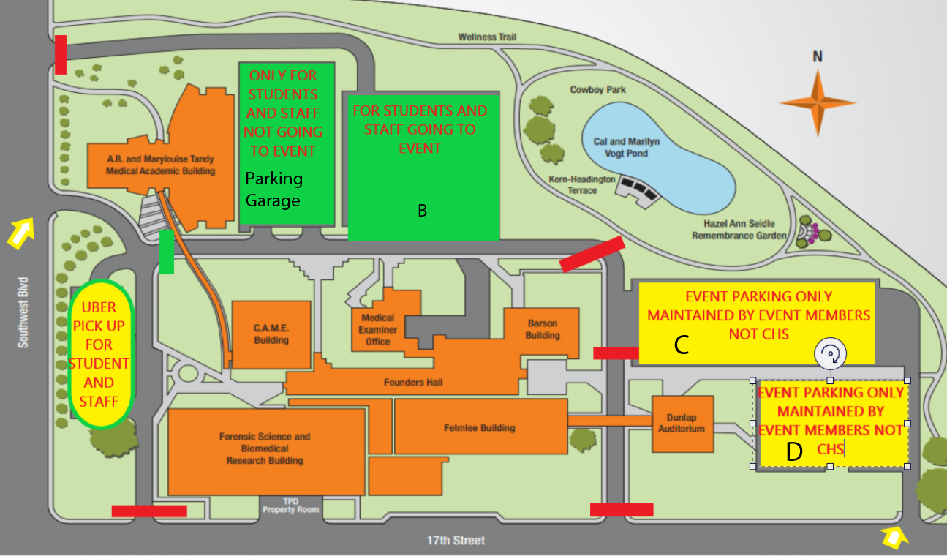

**SAC Communications Committee Meeting: 06-Oct-2019 at 10:00am**

1. SAC Fundraising- some ideas we had to pass on to Fundraising Committee
   1. Could we get approval from administration to raffle the parking spot during United Way.
   2. Selling poinsettias for winter time. Has been a popular thing in years long past.
2. SAC Outreach
   1. Link or re-tweet events on Facebook and Twitter
      1. Could SAC create a Facebook page? Is there a process for this?
   2. Beef up webpage so people interested in joining can
   3. Look at SAC roster and see which departments are underrepresented and reach out to those personally. Ex. Invitation Email
   4. Using Zoom in meetings
      1. Easier to attend meetings and taking notes for the meeting
      2. Can snip out part of the footage if administration wants to discuss private information.
      3. Can set up remote voting
      4. Allows curious people to “try before buying” into the SAC meetings. Would give us information on who to reach out to.
3. SAC Culture
   1. Creating a more social environment so new people and those looking to network more feel invited.
   2. 1-on-1 meet/greet for new members so they feel welcomed to the group
   3. Potluck for one of the lunches (extend meeting by 30 minutes so there is time to chat)
   4. Get to know each other activities
      1. U-Zoo- a personality quiz with a fun game attached
      2. T-Shirt creating day. On a Friday we could create a SAC T-Shirt. This is pending Kelly seeing the pricing for getting SAC shirts professionally done. A previous issue was having to buy too many but there may be a company that would do small orders.
      3. Painting w/ Spirited Canvasses
   5. Holiday party
      1. White elephant gift. Possibly first week of December.

**The Rules and Procedures Committee met on 9/27/19 and 10/10/19 at 9:00am and 2:00 pm,**

**Tandy Academic Medical Building, Room 354.**

1. The Rules Committee discussed the most important thing to focus on at this time, and agreed that the Bylaws were first priority.
   1. The bylaws were split into sections for each member of the committee to review and make adjustments to.
   2. The next meeting was scheduled so that everyone could come together and share discrepancies they found and combine the changes.
2. Michelle send out an electronic copy to all members to make their handwritten changes/edits, and they will send them back to Michelle to compile.
   1. Once all the changes are compiled to a single file, the changes will be presented to the SAC for a vote before sending a final edit to Administration.
3. The major changes that have been pointed out/edited so far are the following:
   1. Put new logo on first page
   2. Defining a “term” as June 1- May 31
   3. A one-year term is the required commitment (rumors of it being two previously)
   4. The budget needs to be audited every year in May
   5. Changing the procedure of voting in new members (right now it is only in April, but want to change it to any time)
   6. Members of SAC will be required to serve on ONE sub-committee, not TWO as previously written
   7. Decide what to do with the dormant committee “Staff Policies and Benefits Committee”
4. Hopefully will have an updated version for a vote in November

Members present: Michelle Loveless, Darlene DuBois, JuLee Wells, Dawn Ballard